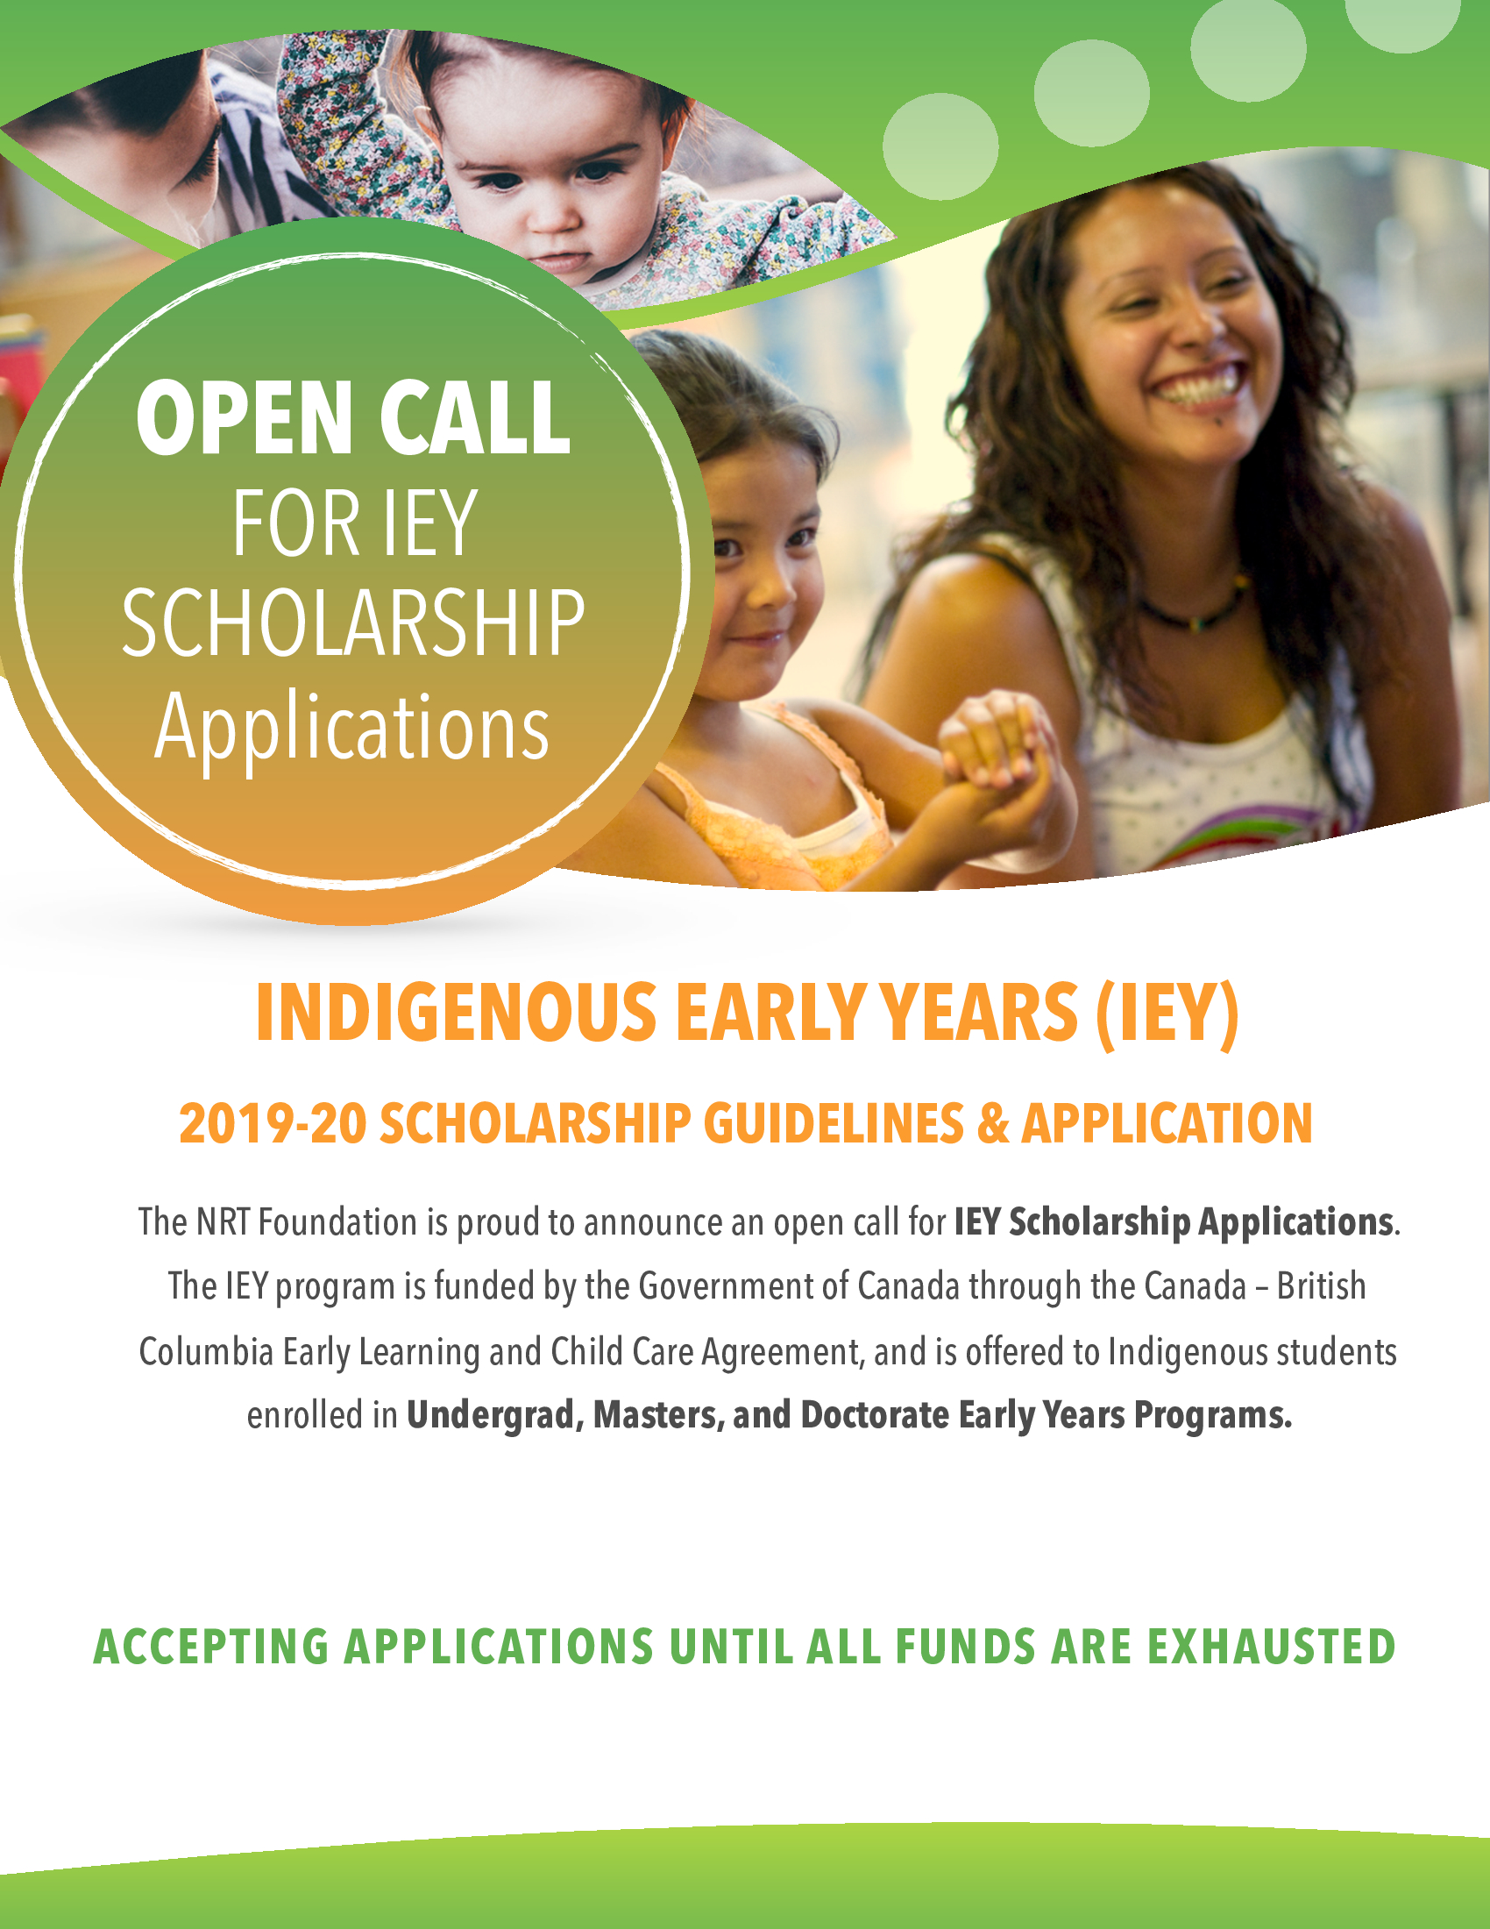

2019-20 Fall Student Scholarship
New Relationship Trust Foundation
Indigenous Early Years Fall Scholarship
Guidelines & Application

The New Relationship Trust Foundation (NRTF) is pleased to announce the 2019-20 Indigenous Early Years (IEY) Fall Student Scholarship program. The program is funded by the Government of Canada through the Canada – British Columbia Early Learning and Child Care Agreement. NRTF is pleased to offer this scholarship to students who currently reside in BC and are enrolled in Early Years programs. Interested and eligible Indigenous students should apply. Call is open until funds exhausted

Scholarships – a limited number is available:
- Full-time Undergraduate scholarships @ $5,000 each per year; Part-time @ $2,500
- Full-time Masters scholarships @ $10,000 each per year; Part-time @ $5,000
- Full-time Doctorate scholarships @ $20,000 each per year; Part-time @ $10,000

When sending in applications:
- Application must have all supporting documents attached, we will NOT accept applications part by part, NO EXCEPTIONS
- NO FAXES - Faxed applications will not be accepted.
- Completed IEY scholarship applications can be mailed, dropped off or emailed to scholarship@nrtf.ca

Eligibility:
Indigenous: First Nations, First People, Métis and Inuit people of Canada. Those who identify as Indigenous persons and are residents of BC are eligible for the Indigenous Early Years Scholarship Program in areas of study that align with early years’ professions including early childhood education, early intervention therapies and supports, and other para-professions.

Eligible Program types: | Ineligible Program types:
- Undergraduate, Master’s and Doctorate Degree Programs | - Certificate programs  - Diploma programs  - Associate Degree programs  - Conferences / symposiums / workshops  - Professional Fees / schools  - Non-recognized post-secondary institutions  - Executive / Management program

Areas of study include but are not limited to:

- Early Childhood Education (Basic, Infant Toddler or Special Needs)
- Child, Family and Community
- Child and Youth Care
- Human and Social Development
- Speech and Language Pathology
- Speech and Language Assistants
- Occupational Therapy
- Physical Therapy
- Behavioral Analysts
- Applied Behavioral Sciences
- Educational Psychology
- Social Work
- Language Revitalization

Other programs may be applicable based on the discretion of New Relationship Trust. Students enrolled in distance or online courses at an accredited institution outside of B.C. or Canada can apply. However, they must reside in B.C. during their studies and must show proof of their enrollment.

Renewal Criteria
- All students must re-apply each year
- Returning students must have a C+ (2.3 GPA) average to qualify for subsequent school years
- Returning students must submit a copy of their transcripts

Additional Funding Opportunities:
*please note we are not affiliated with these funding streams. If you are interested in accessing these resources, and/or require more information, please reach out directly to the contacts listed in the links provided below.

BC Government’s Provincial Tuition Waiver Program: The Provincial Tuition Waiver Program supports B.C. students who are former youth in care who are attending either full-time or part-time studies at a B.C. public post-secondary institution, Native Education College or one of 10 eligible union trades training centres (see full list by following this link)

ECEBC’s Early Childhood Education (ECE) Student Bursary Program: This program is open to all ECE students enrolled at an accredited ECE post-secondary institution. Students are eligible to receive up to $4,000 in funding per school semester. Click here to access more information.

Required Scholarship Application Documents:
Supporting Document | Acceptable Items | Unacceptable Items
Application form | - Fully completed form  - Signed and dated  - All information is true  - Clearly written form  - Scanned application forms | - Incomplete form  - Not signed or dated  - Inaccurate or false information  - Illegible form  - Phone pictures of application form
Essay | - 500 words (1-2 pages typed)  - What are the most important issues your desired field is facing today and how would your education meaningfully impact these issues within your community? | - Essays exceeding 500 words  - Unoriginal essays (i.e. speeches or essays used in past applications)  - Reused version from previous application year
Community Involvement | - One page on your involvement with an Indigenous Community | - Exceeds one page  - Community involvement included in your vision essay. Must be separate.
Letter of Support from your First Nation, Métis, or Inuit Community on letterhead(Contact Marie Alaimo if obtaining this is an issue) | - Letter stating that you have support to apply for this scholarship  - On letterhead from your Community  - Dated this year | - Letter from a non-community based organization  - Outdated letters
Proof of Citizenship or Membership to First Nation, Métis Nation, or Inuit community | - Letter from your Indigenous community (on letterhead) stating you are considered a member  - Or a photocopy of Status or Citizenship card (If Métis, card or a letter from a Métis organization is acceptable) | - Letter from anywhere else other than your Indigenous community
Latest unofficial Transcripts | - Unofficial or Official Transcripts  - From most recent school year  - Envelopes do not need to be sealed | - Written on transcripts  - Note: Original official transcripts will be required if approved
Acceptance/Fall Enrollment at Post- Secondary Institution | - An Acceptance Letter is required if going into a new institution  - Returning students must submit a letter of Fall enrollment  - Dated this year and on school letterhead | - Outdated letters from previous years  - Letters from anywhere else other than the institution  - Screenshots of online registration with no logos
Proof of residence in the province of British Columbia | - Photocopy of BC Driver’s License or Health Card  - Photocopy of BC lease agreement  - Photocopy of BC Utility Bill | - Non-BC Driver’s License or Health Card  - Non-utility bill
Resume | - Up to date Resume or CV | - Outdated or incomplete

Frequently asked questions
Question: I received an award last year; do I need to reapply?
Answer: Yes, each year students need to reapply. Past recipients must show they have kept up their C+ (2.3 GPA) average to qualify for the subsequent school year. Past recipients should also describe in their essay any work you have performed (paid or volunteer) to strengthen your community.

Question: I do not have my status, am I still eligible?
Answer: Yes, if you are considered a member of a First Nation, Inuit or Métis Community but do not have status, you can get a letter of support stating you are a non-status member from your Indigenous Government.

Question: I have status from another province/Non-Status/Métis/Inuit Student, can I apply for an NRTF IEY Award?
Answer: YES. This IEY awards program is open to all Status, Non-Status, Métis, or Inuit students who are residents of BC and are planning on attending ECE related programs. Please go to www.nrtf.ca for more info.

Question: I am Indigenous and living in BC but doing my studies outside of BC. Am I still eligible?
Answer: Yes, this application is only for Indigenous students who are residing in BC and are studying ECE related programs. Applicants who reside in BC and are studying ECE related programs by distance education and/or online are eligible.

Question: I am getting my Diploma or Trades/Certificate, but I can’t find that information on this application?
Answer: This application is ONLY for early years undergrad, masters and doctorate programs. If you are not in either of these programs, please refer to the NRTF Bursary program.

Question: I’m only registered for part-time studies; do I still qualify?
Answer: Yes. For undergrad, part-time is defined as the student taking no less than 2 courses; for full-time, each institution has their definition and NRTF requires ‘full-time’ to be stated on a school document – by way of letter (on letterhead), signed by a supervisor or department head. Masters and Doctorate programs must be considered full-time or in good standing by their institution to qualify and are required to provide a letter from their instructor and institution to support this. You can apply for funding if you are going to school for one term – you will receive half of the scholarship you are applying for an

Question: I have already graduated, am I eligible?
Answer: No, applicants must be attending school after the scholarship has been awarded (typically in August).
Question: What field of studies are eligible?
Answer: This application is specifically for Early Years related programs. See eligible programs on page 3 of this document.

Question: My registration date isn’t until after the application deadline.
Answer: We do not need confirmation of registration until after the scholarship has been awarded; we just need a letter of acceptance or enrollment. Enrollment indicates you are considered a student at the institution; however, you have yet to register in classes.

Question: My acceptance letter is dated last year because I’m in my 2nd year, is that acceptable?
Answer: No, if you are already accepted into the institution then a letter of enrollment will be needed rather than a letter of acceptance.

Question: I cannot get a hold of my First Nation/Métis/Inuit Government; will a letter from anyone else suffice? Or from an Indigenous community where I currently live?
Answer: We require an official letter of support from the First Nation/ Métis/Inuit government you are registered with or considered a member of. We will accept a letter from the Indigenous community that you are connected to. If you are having trouble with this requirement, please contact Marie NRT office or email scholarship@nrtf.ca for assistance.

Question: Can I have my education institute send the transcripts or confirmation of enrollment directly to NRT?
Answer: No, applications must be complete when submitted by the student. This ensures that you know your application is complete before the deadline. Due to a high volume of applications, we cannot consider applications that are sent incomplete or piece by piece.

Question: Do I need my original official transcript?
Answer: No, unofficial transcripts will suffice until you are approved. If you are approved, you will be asked to supply additional information, including your original official transcripts. If you do supply the original official transcripts in the application, then you will not be asked for it again.

Question: When will I find out if my application has been approved?
Answer: Please contact Marie at the NRT office or email scholarship@nrtf.ca for this information.

Question: If my application is approved when will I receive my first cheque?
Answer: When you are approved, you will be provided with a letter and instruction of further items we will need. They will be confirmation of registration, picture and biography official transcripts from past year, and a course list. Once those items are received your cheque will be mailed to you. The second cheque is sent in the second term, following receipt of second term course list, official transcript and confirmation of full-time/part-time enrollment.

Question: I need clarification on this application, who do I speak to?
Answer: If you have any questions about the NRTF Scholarship, call Marie Alaimo at 1-877-922-3338.
NRTF Indigenous Early Years Fall/Winter Scholarship

Before completing your application please read the NRTF Scholarship Guidelines to ensure you qualify for this award. Once you have completed filling in your application and before submitting it, please ensure that it contains all of these important documents. Copies are acceptable:
□ Completed and signed 2019/20 IEY application form (the following pages 1 to 4)
□ Essay: What are the most important issues your desired field is facing today and how would your education meaningfully impact these issues within your community?
□ One-page summary on your involvement within the Indigenous Community
□ Letter of support from your First Nation, Métis, or Inuit community on letterhead (contact Marie Alaimo if this is a challenge for you)
□ Proof of First Nation (status and non-status), Métis, or Inuit citizenship/membership
□ Proof of British Columbia residence
□ Unofficial Transcript of most recent academic record (official one will be necessary if you are approved)
□ Acceptance letter at recognized accredited institution or associations
□ Resume/CV

*Applications must have all supporting documents attached when submitted. Do NOT attach guidelines or this page when submitting your application.

Due to demand, incomplete applications will not be considered.

Please retain copies of your application materials because original submissions will not be returned.

DO NOT FAX APPLICATIONS. Please mail/email/hand-deliver completed applications to:

NRTF Post-Secondary Scholarship Awards
New Relationship Trust Foundation
3188 Alder Court
North Vancouver, British Columbia V7H 2V6
scholarship@nrtf.ca
Attention: Marie Alaimo, Senior Project Officer
Personal Information:
*Name and address given will be used on disbursement cheques
Legal First Name |  | Legal Last Name |  | Middle  Initial

Mailing Address
Unit #: |  | Street Address:

City |  | Province |  | Postal Code

Home Phone |  | Cell

Email Address
* All applicants will be notified of their application status by email

Which Indigenous Nation are you a member or citizen of?
Status |  | Non-Status |  | Métis |  | Inuit

Which Indigenous community are you a member or citizen of?
*Applicants must be a member of an Indigenous Community and show support from the Community directly

Enclose a letter from a person in authority within the administration of your Indigenous Community verifying your membership or citizenship in the Community, together with the person’s position, address and telephone number if you do not have a status card or citizenship card. If you have any questions, please contact Marie at scholarship@nrtf.ca.

Person’s name and position:
Person’s telephone number:

Have you ever been awarded an IEY or NRTF Bursary or Scholarship before?

Yes No

If yes, please indicate:

Type: |  | b) Year: |  | c) Value of Award: | $

Post-Secondary or Training Institution Information:

Post-Secondary Institution:

Please indicate which Scholarship you are applying for: _______________________________________________
*Scholarships are not available for Certificate, Diploma, or Associate degrees. Please apply for the NRTF Indigenous Early Years Bursary
Major/Program Name:

Are you a returning student? |  | Yes | No |  | If Yes, GPA last year:
 |  |  |  |  |  |  | (Attach copy of transcripts)
Year Attending (ex. 2^{nd,} 3rd, 4th):

Expected Graduation Date:

Indicate which terms and number of credits per term you plan to enroll in 2019-2020, and whether it’s part-time, full-time or half-time (it is important you indicate this):
* Masters/Doctorate students must provide a letter from their instructor and institution to confirm/support full/part-time status
Months/Terms | Credits | Full Time* | Part Time (min. 2 courses) | Half-Time (going to school for one term only)
* Full-time usually means the student is taking a minimum of four courses per semester

Funding Sources:
If you are applying for a Canada/BC student loan and/or other student funding sources, please indicate:
Canada Student Loan Amount Applied for:
Date of Application:
British Columbia Student Loan Amount Applied for:
Date of Application:
Other Student Funding Source(s) applied for:
Name(s) of Funding Source:
Date of Application:

Have you approached your Indigenous Community for funding? Yes No
If No, state why

Has your Indigenous Community agreed to fund you? Yes No Awaiting Decision
How much will you receive? | $ | If No, state why

Will you be receiving funding assistance from other sources for your education costs or living expenses?
Yes No
If yes, what sources and what amounts?
Source |  | Amount | $
Source |  | Amount | $
Employment:
Are you currently employed? Yes No
If No, how long have you been unemployed? | Months |  | Years
If Yes, how long have you been employed? | Months |  | Years
Name of Employer:
Contact Person:
Contact Info:
Annual Employment Income:
Length of Employment:
Job Title:

Will you be employed during the School Year? |  | Yes |  | No

Budget: (for one academic year)
please include all sources of expenses and income during your school terms.

 | Expenses |  |  | Sept-Dec |  | Jan-April | May-Aug |  | Total | Income |  |  | Sept-Dec |  | Jan-April |  | May-Aug |  | Total
 | Tuition & Fees |  |  |  |  |  |  |  |  | Employment
 | Books |  |  |  |  |  |  |  |  | Family/Personal
 | Rent/Mortgage |  |  |  |  |  |  |  |  | Community Living Allowance
 | Utilities |  |  |  |  |  |  |  |  | Community Tuition
 | Food |  |  |  |  |  |  |  |  | Community Books
 | Transportation |  |  |  |  |  |  |  |  | Scholarships
 | Child Care |  |  |  |  |  |  |  |  | Bursaries
 | Clothing |  |  |  |  |  |  |  |  | Student Loan
 | Other (identify) |  |  |  |  |  |  |  |  | Other (identify)
 | Total |  |  | $ |  | $ | $ |  | $ | Total |  |  | $ |  | $ |  | $ |  | $
 |  |  |  |  |  |  | Please explain any unique budget circumstances below:
How did you hear about the IEY Scholarship?
NRT Website |  |  |  |  | Facebook |  |  | Community |  |  |  | School |  |  |  | Twitter |  |  |  | Other

Other, please specify: ________________________________________________________

Verification of Information

I understand that the information submitted in and with this application will be used to assess my eligibility for the Indigenous Early Years Fall/Winter Scholarship Award. I hereby certify that all the information provided on this application form and in all the documents accompanying it is true, accurate and complete. I have read all the policy and guidelines regarding the Indigenous Early Years Fall/Winter Scholarship. By submitting this application, I agree to be bound by the policies and guidelines of this initiative. I give my permission to the NRT Foundation and its partners to collect my contact information so that I may receive information about potential employment, scholarship, and training opportunities.

Signature Date

Print Name

